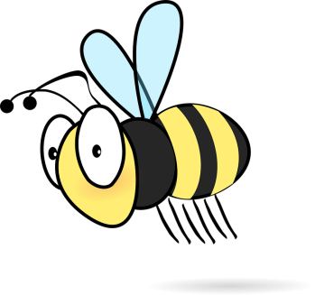

Christmas Survival Kit

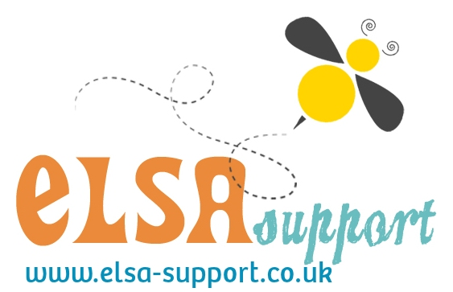

Please do not share this resource but direct people to the website where they can download their own copy.

Website: [www.elsa-support.co.uk](http://www.elsa-support.co.uk)

Facebook: <https://www.facebook.com/ElsaSupport/>

Instagram: elsa_support

Twitter: <https://twitter.com/elsasupport>

Facebook TA Group: <https://www.facebook.com/groups/1067187199968259/>

Facebook ELSA Secret Group: Contact info@elsa-support.co.uk for your invitation

Pinterest: <https://uk.pinterest.com/debbiepalp/>

Dear Samantha, here are a few things to make your Christmas Special:

* A crayon – to colour your day bright and cheerful.
* A mirror- to remind you how unique you are.
* An eraser – to show that mistakes can fade.
* Bubbles – to blow your worries away.
* A Kit Kat – to remind you to ‘take a break’.

From Mrs. Palphreyman

Dear Samantha, here are a few things to make your Christmas Special:

* A crayon – to colour your day bright and cheerful.
* A mirror- to remind you how unique you are.
* An eraser – to show that mistakes can fade.
* Bubbles – to blow your worries away.
* A Kit Kat – to remind you to ‘take a break’.

From Mrs. Palphreyman

Dear Samantha, here are a few things to make your Christmas Special:

* A crayon – to colour your day bright and cheerful.
* A mirror- to remind you how unique you are.
* An eraser – to show that mistakes can fade.
* Bubbles – to blow your worries away.
* A Kit Kat – to remind you to ‘take a break’.

From Mrs. Palphreyman

Dear Samantha, here are a few things to make your Christmas Special:

* A crayon – to colour your day bright and cheerful.
* A mirror- to remind you how unique you are.
* An eraser – to show that mistakes can fade.
* Bubbles – to blow your worries away.
* A Kit Kat – to remind you to ‘take a break’.

From Mrs. Palphreyman

