A picture containing thing, object

Description generated with very high confidence

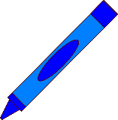

NAME

NAME



NAME

NAME



NAME

NAME



NAME

NAME