Social story
How to explain autism to an autistic child

Please do not share this resource but direct people to the website where they can download their own copy.
Website: www.elsa-support.co.uk
Facebook: https://www.facebook.com/ElsaSupport/
Instagram: elsa_support
Twitter: https://twitter.com/elsasupport
Facebook TA Group: https://www.facebook.com/groups/1067187199968259/
Facebook ELSA Secret Group: Contact info@elsa-support.co.uk for your invitation
Pinterest: https://uk.pinterest.com/debbiepalp/
Please do not print this page.

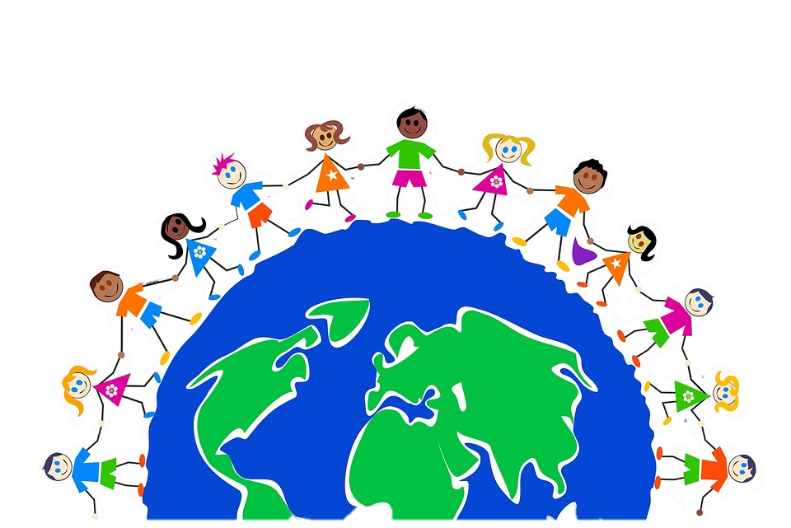
Social story to explain autism to an autistic child
There are thousands of children born every day in the world and every single child is special in some way. Every child is unique. Every child has a special talent or strength.

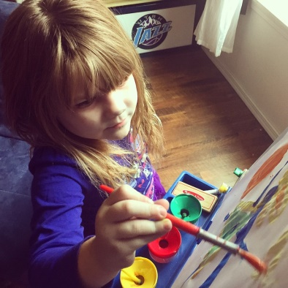
Some children can run fast, some children can play musical instruments, some children can draw the most amazing pictures and some children can write the most amazing stories.

Some children are special because they have autism. It is ok to be born with autism. It is ok to be autistic.
No one knows why someone is born with autism just as no one knows why some children are born who can draw better than others or sing better than others or run faster than others or write better stories than others.
Autism can mean different things to different children. To you it means (make individual for the child but focus on what they CAN do).

It is ok to have autism. Lots of children all over the world have autism. There are children in the UK, America, Africa, France, Spain, China, Japan, etc.

You are part of a very special group of children (and adults), because autistic children grow up into autistic adults.
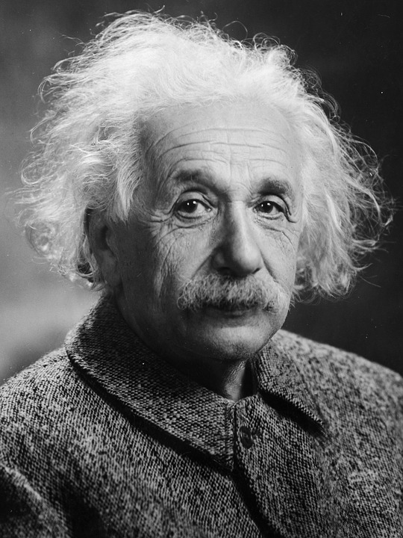
There are some very special autistic adults who have done amazing things such as (write some famous autistic adults here that he might know such as Einstein, Mozart, or Hans Christian Anderson. You could also write about the things these people have done that is so special especially if it appeals to the interests of the child. Eg. Mozart wrote beautiful music that everyone listens to today, Hans Christian Anderson wrote amazing stories for children).

Your parents love you and are so proud of you for who you are, your friends love you and are so proud of you for who you are and your teachers love you and are so proud of you for who you are. Everyone loves you for being you!
You must always remember it is ok to have autism and you are part of a very special group. One day you might become very famous just like those autistic adults we talked about if you use all those talents that you have.
You should always feel proud of yourself for who you are. We are all very proud of you.
Do add some photos to make this more personal – a school photo, children showing differences in strengths and talents, photos/pictures of famous people.

